ME 777

Executive summary

Rocket analysis

To properly analyze the stability of a rocket we must first understand the forces acting on the body. The three main forces of interest for our analysis are drag, thrust and gravity. Gravity will be ignored because our rocket is small and made of carbon fiber, making its weight a negligible force. There are two components of total drag force that will be taken into account: Pressure drag and friction drag. Pressure drag is caused by high to low pressure gradient from the nose of the rocket to the aft end. This gradient is dependent on the cross sectional geometry of the rocket. Friction drag is due to the friction from the interaction between a viscous liquid and a solid surface. There are other forms of drag on rockets, however they are either negligible or out of scope of this project. Drag is of high concern as it is the primary resistive force in rocket propulsion and needs to be understood and deeply analyzed for successful flight. Another area of concern is buckling. The thrust from our I224-15A engine is expected to hit maximum thrust in about .3 seconds. This will produce a massive thrust in a very small amount of time. It is our thought that this could lead to instantaneous buckling during launch. A buckling analysis was performed to confirm if this was a considerable mode of failure.

A flow simulation was completed to calculate the friction drag and pressure drag at the maximum rocket velocity. Sea level properties of air were assumed, and a free stream velocity of 583 m/s was applied. This free stream velocity was approximated using an open source software called OpenRocket, which can estimate the maximum velocity of the rocket during its trajectory. The results can be seen in table 1. As you can see in figure 1 the pressure is high at the front and low at the back, creating the pressure drag described earlier.

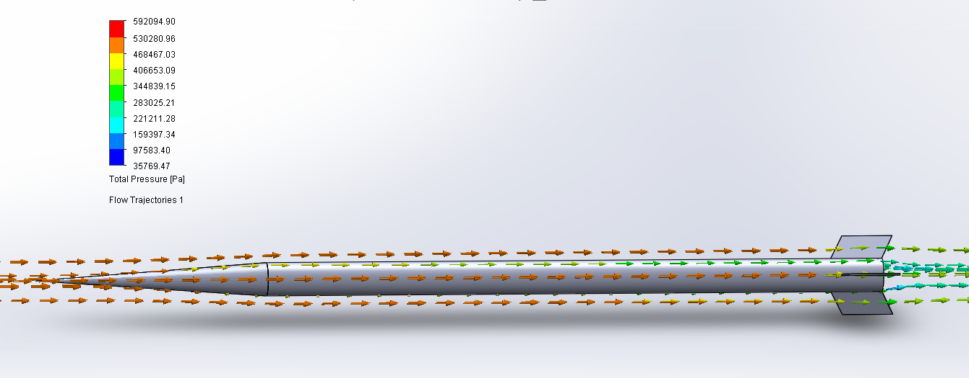

Figure 1: Trajectory flow demonstrating pressure gradient

A buckling analysis was ran to calculate the buckling factor of safety of the rocket. To correctly model the instantaneous buckling, one end was completely fixed while the other was only constrained laterally. These constraints make the assumption that when the thrust is maximum, the other end is statically resisting the force. The free end is laterally constrained as the rigidity of the entire assemble prevents lateral displacement. An axial force of 430 N from the engine is applied to the free end. The results from the study can be seem in table 1. The deflection seen in figure 2 is expected for tube buckling, as it is collapsing in on itself. It is also important to note the deflections are very minimal.

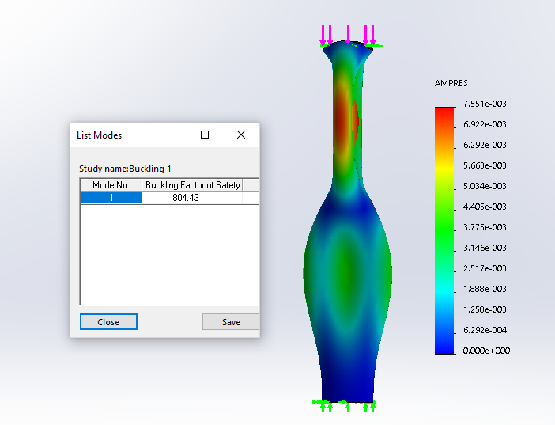

Figure 2: Tube Buckling simulation

Table 1: Analysis Results Comparison

|  |  |  |  |
| --- | --- | --- | --- |
| **Analysis** | **Hand Calculation** | **Simulation** | **% Difference** |
| Buckling Factor of Safety | 824.07 | 804.43 | 2.7% |
| Pressure Drag | 20.7 N | 14.07 N | 32% |
| Friction Drag | 29.62 N | 26.84 N | 10% |
| Total Drag | 50.32 N | 40.93 N | 23% |

The buckling factor of safety proved to be the most accurate. This is can be explained by the similarity between the hand calculation model and the SolidWorks model. Pressure drag results seem to be in disagreement. This is most likely due to the use of an approximated coefficient of drag based on the nose cone shape. In practice coefficient of drag values tend to be experimentally measured, producing more accurate results. Friction drag is quite accurate with small discrepancies. For the friction drag hand calculations we only took into account the surface area of the nose cone and the body tube, ignoring the fins. Surface roughness was also ignored in the hand calculations, but taken into account for the simulation.

A preliminary simulation was deemed unnecessary for both analyses because the geometry of a rocket was simple enough to have the same exact models for both the simulations and the hand calculations.